MLS PROCESS DOCUMENT FOR AUTOMATION TOOL

MLS (Multiple Listing Service):
- The primary purpose of an MLS is to provide a mls num comparison for Residential Sales Team & Residential Appraisers Team. We will be uploading all the Listed & Sold Properties in to our database. Source file will be receiving from Respective MLS Site.
- MLS Automation Tool is using for Houston, Austin, San Antonio, Dallas Metro & Non-Core. The files belongs for theses metros will be working in MLS Automation Tool.

Process Flowchart:
MLS AUTOMATION TOOL
(METRO: HOUSTON, SAN ANTONIO, DALLAS, AUSTIN, NON-CORE)

Download the Sales from the respective MLS Site. Based on the Date

Append the Sales in to Database using MLS Automation Tool

Tool will display the sales that to be process

Find the Account Number from CAD Site and Update the Account Number & LUC for the respective Address and Legal Description

Verify the Mandatory Fields, Save & Complete the Record.

Core Metros
Core Metros: – Houston, Dallas, San Antonio, Austin
Downloading:
Houston Metro
Source Link: http://www.har.com
User id: oconnorp
Password: mls2016
Step 1:
By using the user id & password login the MLS site. Click on Matrix MLS.
Screenshot:
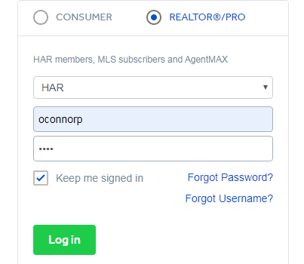

Step 2:

Click on Single family and select classic
Screenshot:


Step 3:
For Listing Files select the entire status in status column except sold and Enter the required downloading from and to date. Select the entire property sub type.

Screenshot:
Listing:
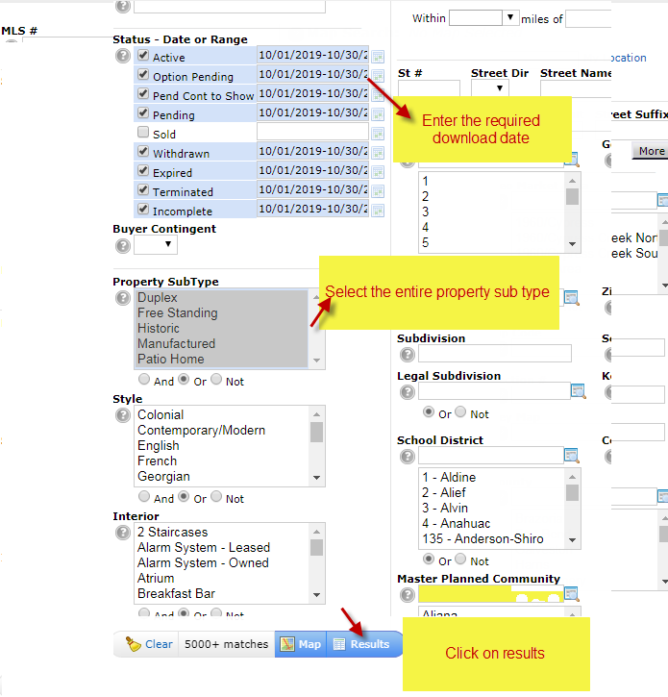

Sold:
For Sold Files select the sold status in status column and Enter the required downloading from and to date. Select the entire property sub type.

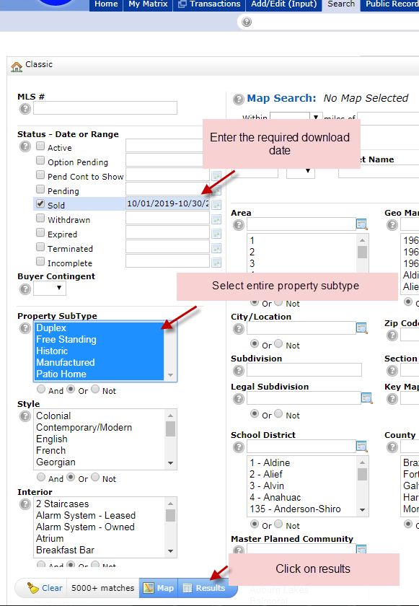

Step 4:
Select all and click on export.

Screenshot:

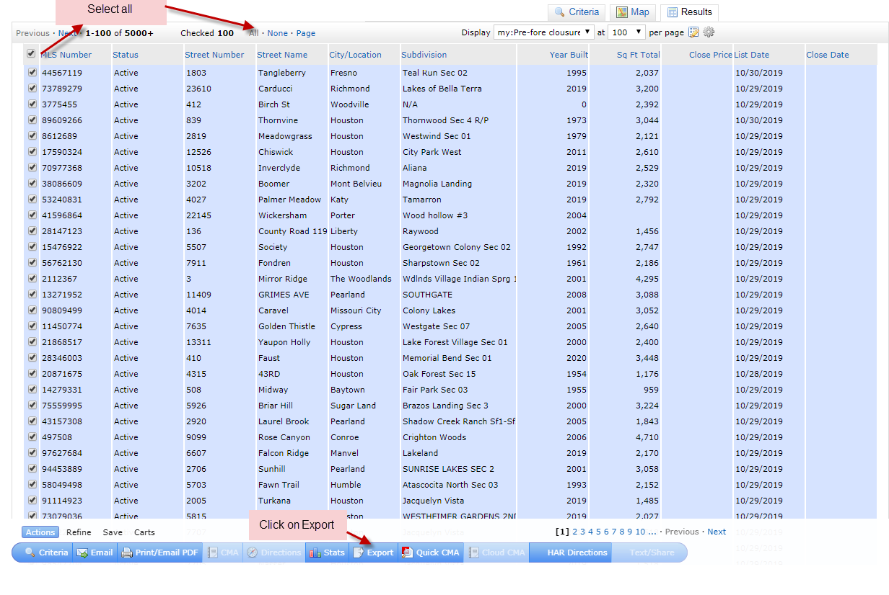

Step 5:
Select New Export Tab & click on Export. Files will be downloaded.
Screenshot:

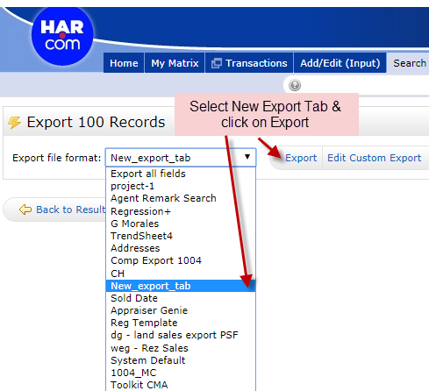

Houston Other Property Types:
Other property types will be downloaded yearly once. Other property types such as Multifamily, Lots, Townhouse/Condo, Country Homes/Acreage, Mid/Hi Rise Condo.

Note: Same Procedure for Lots, Townhouse/Condo, Country Homes/Acreage, Mid/Hi Rise Condo Like Residential Files

Screenshot:
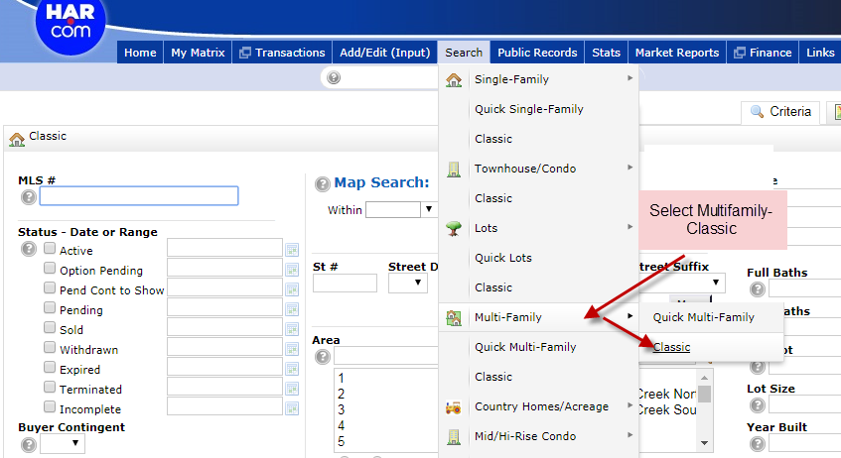

Dallas Metro

Source Link: https://idp.ntreis.safemls.net/idp/Authn/UserPassword

User id: D101113
Password: Dallas1!

Step 1 :
By using the user id & password login the mls site.
Screenshot: 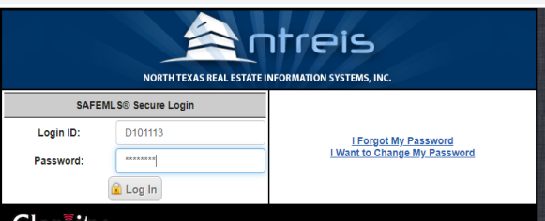
Step 2:
Click on ntries matrix.

Screenshot:
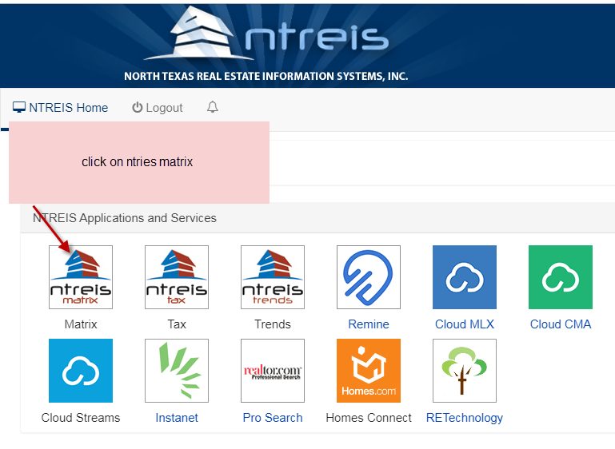

Step 3:
For Listing Files select the entire status in status column except sold and Enter the required downloading from and to date. Select the entire property sub type.
Screenshot:
Listing:
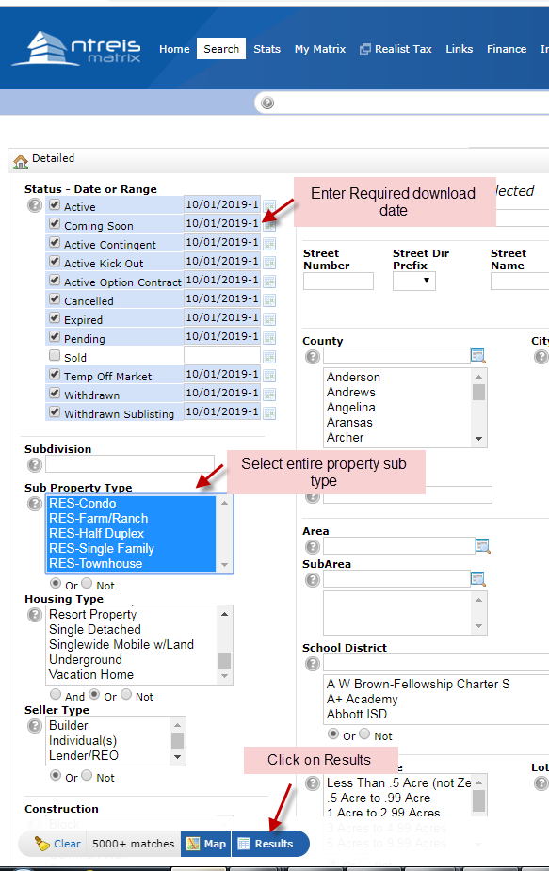

Sold:
For Sold Files select the sold status in status column and Enter the required downloading from and to date. Select the entire property sub type.
Screenshot:
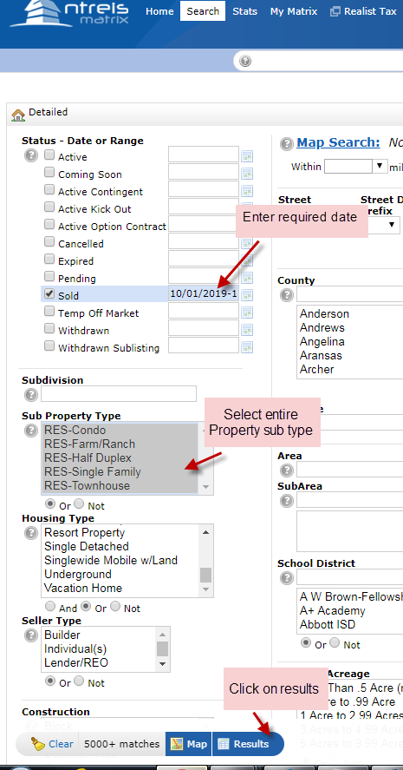
Step 4:
Select all and click on export.

Note: Same like Houston Metro.
Step 5:
Select Updated Res & click on Export. Files will be downloaded.

Screenshot:
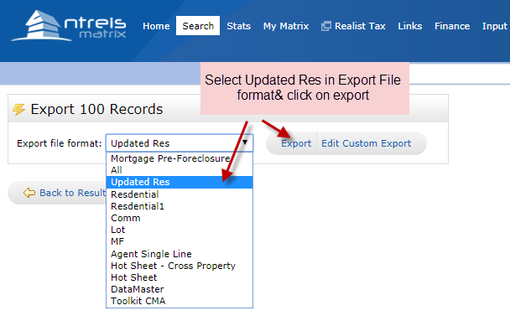
Dallas Other Property Types:
Other property types will be downloaded yearly once. Other property types such as Multifamily, Commercial, Lots & Acreage.
Note: Same Procedure for Commercial, Lots & Acreage

Screenshot:
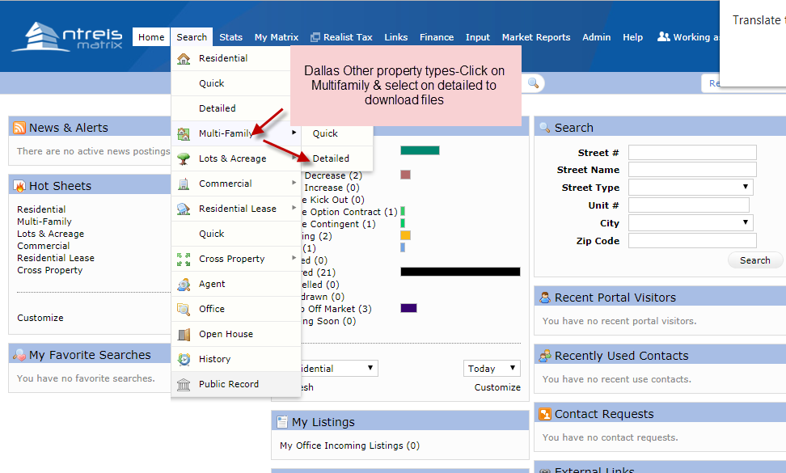

Step 1:

For Listing Files select the entire status in status column except sold and Enter the required downloading from and to date. Select the entire property sub type.

Screenshot:
Listing:
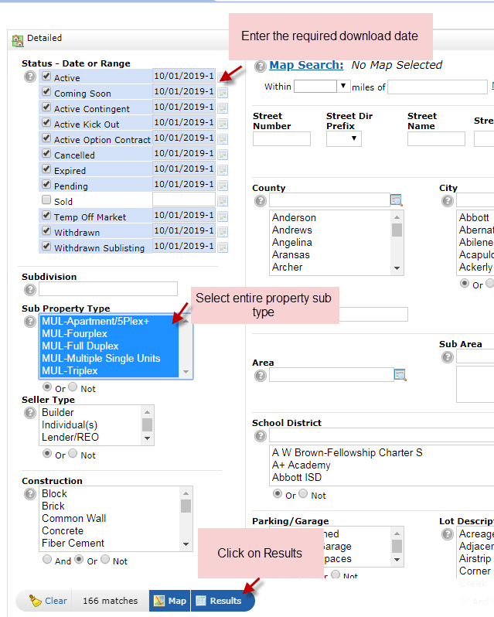

Sold:

For Sold Files select the sold status in status column and Enter the required downloading from and to date. Select the entire property sub type.

Screenshot:

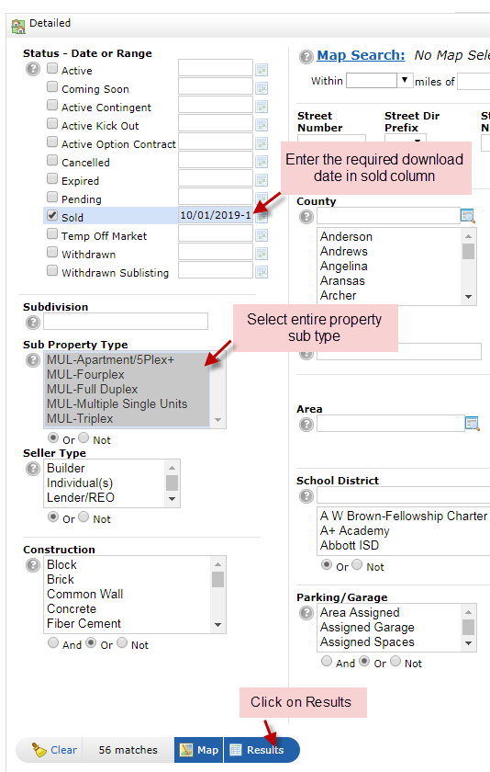

Step 4:
Select all and click on export.
Note: Same like Houston Metro.
Step 5:
Select Updated Res & click on Export. Files will be downloaded.

Austin Metro

Source Link: http://www.abor.com
User id: 104846PA
Password: 33OCONNO

Step 1 :
By using the user id & password login the mls site.

Screenshot 1:
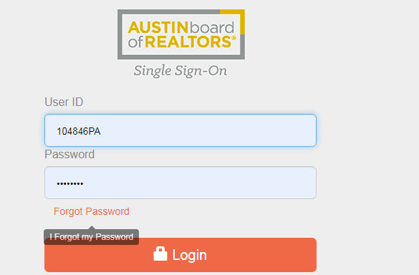

Screenshot 2:
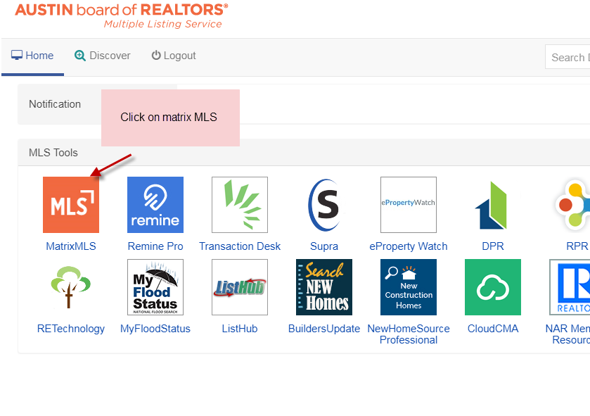
Screenshot 3:
Select Residential and click Detailed.
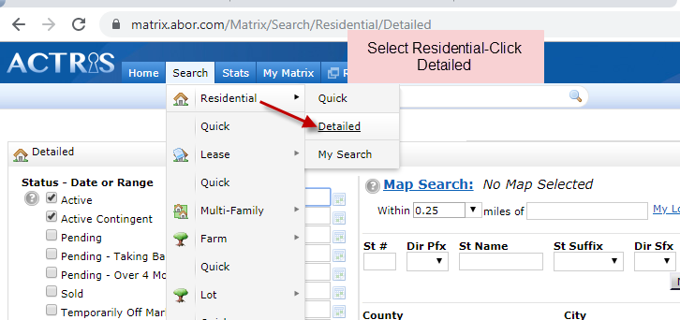

Step 3:
For Listing Files select the entire status in status column except sold and Enter the required downloading from and to date. Select the entire property sub type.

Screenshot:
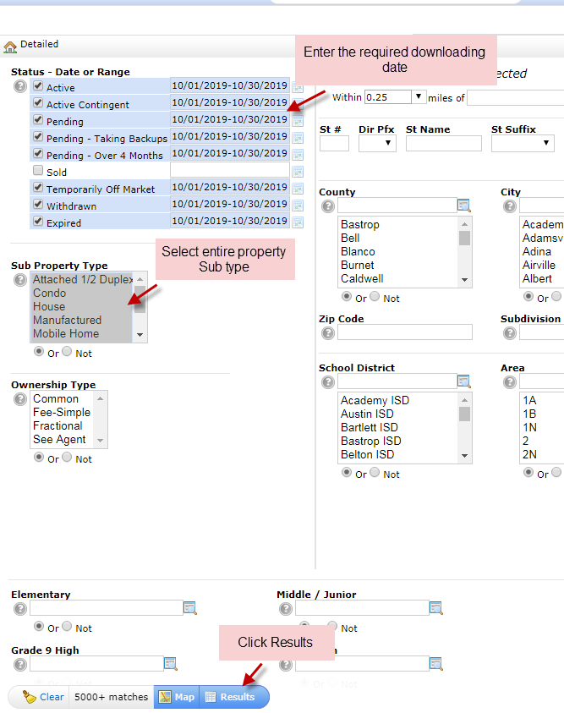

Step 4:
Select all and click on Export.

Screenshot:
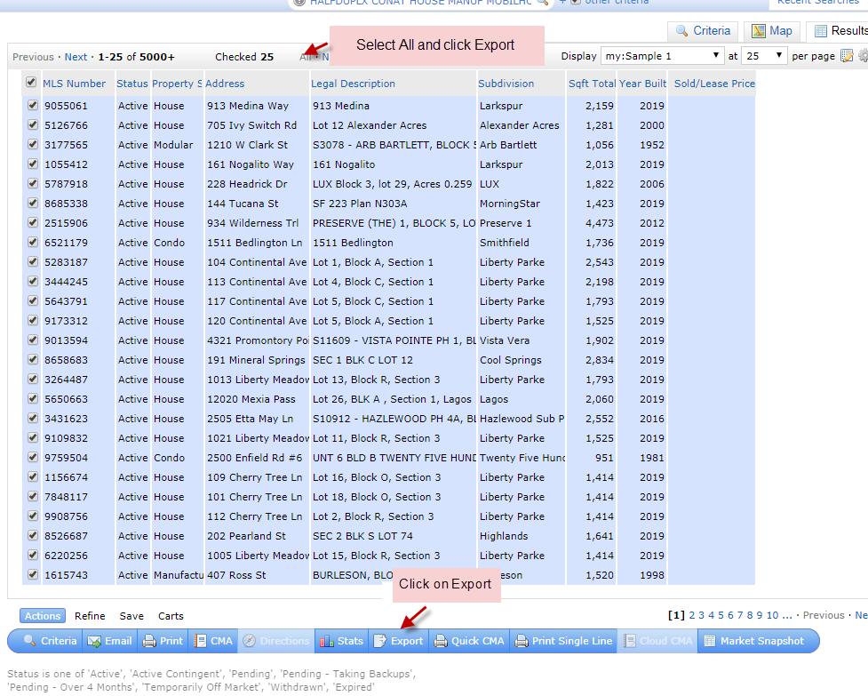

Step 5:
Select Residential and click on Export. Files will be downloaded.
Screenshot:
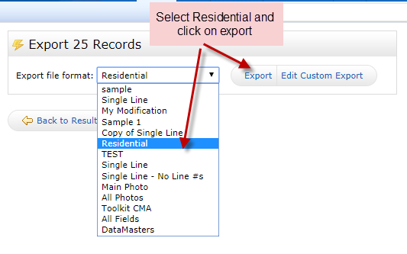

Sold:
For Sold Files select the sold status in status column and Enter the required downloading from and to date. Select the entire property sub type.
Note: Same procedure like Listing
Screenshot:
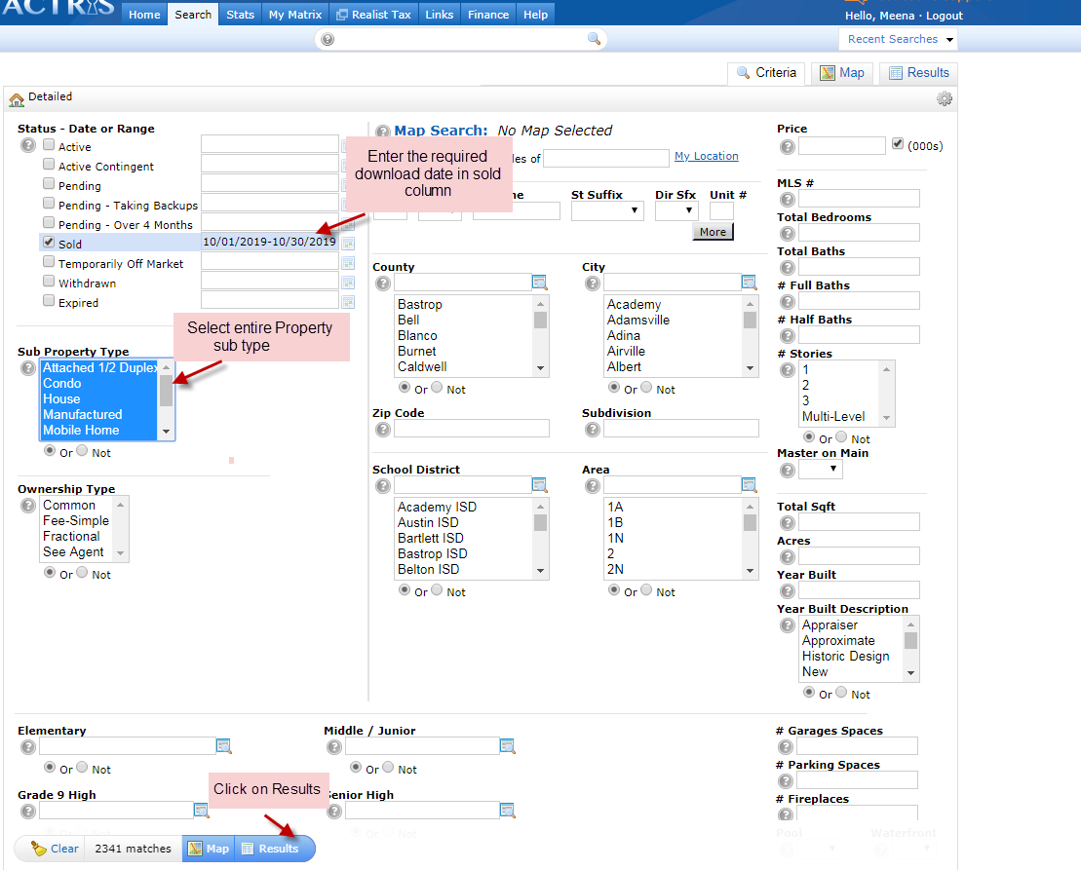

Austin Other Property Types:
Other property types will be downloaded yearly once. Other property types such as Multifamily, Commercial, Lots & Farm.
Note: Same Procedure for Commercial, Lots & Farm like Residential

Step 1:
Select Multifamily and click on detailed to download files.
Screenshot:
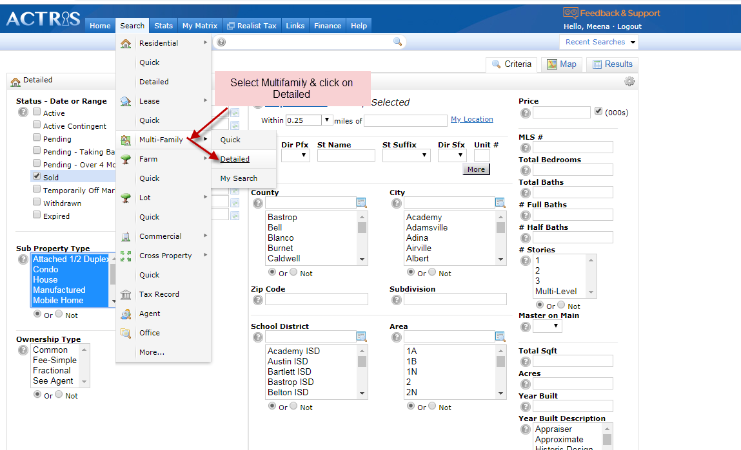
Step 2:
For Listing Files select the entire status in status column except sold and Enter the required downloading from and to date. Select the entire property sub type.
Screenshot:
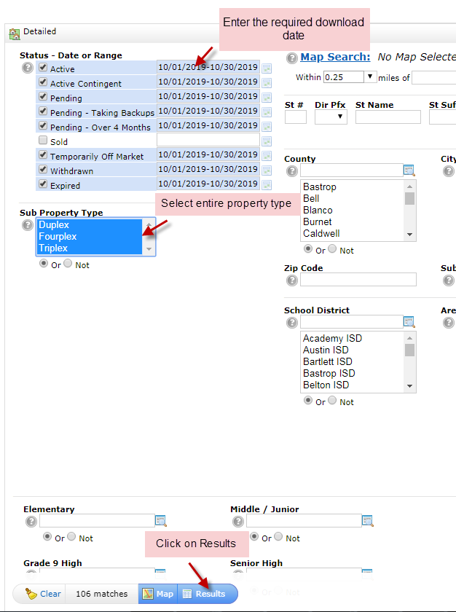
Step 3:
Select all and click on Export.
Screenshot:
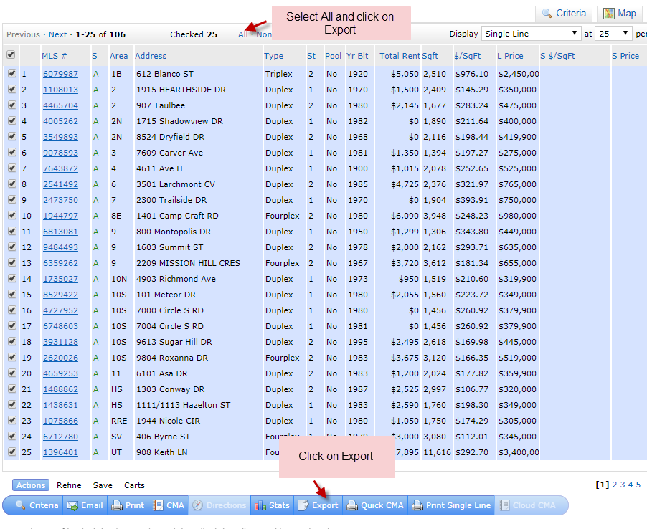
Step 4:
Select on Multifamily and click on Export. Files will be downloaded.
Screenshot:
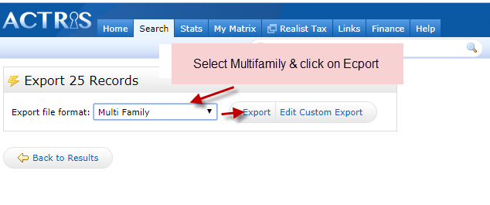
San Metro

Source Link: http://sabor.connectmls.com/
User id: 330995
Password: pass@2019

Step 1 :
By using the user id & password login the mls site. Click on Clients and Service Partners.
Screenshot:
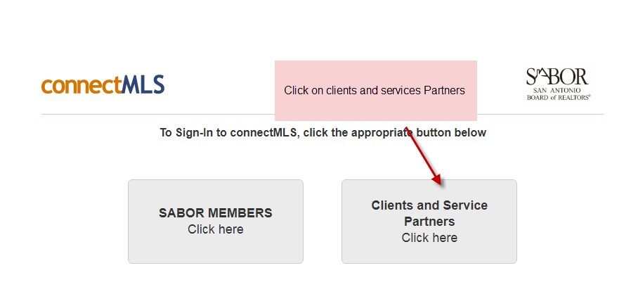

Step 2:

Select Residential Active-Pending Search New For Listing & Select Residential Search For Sold.

Screenshot:
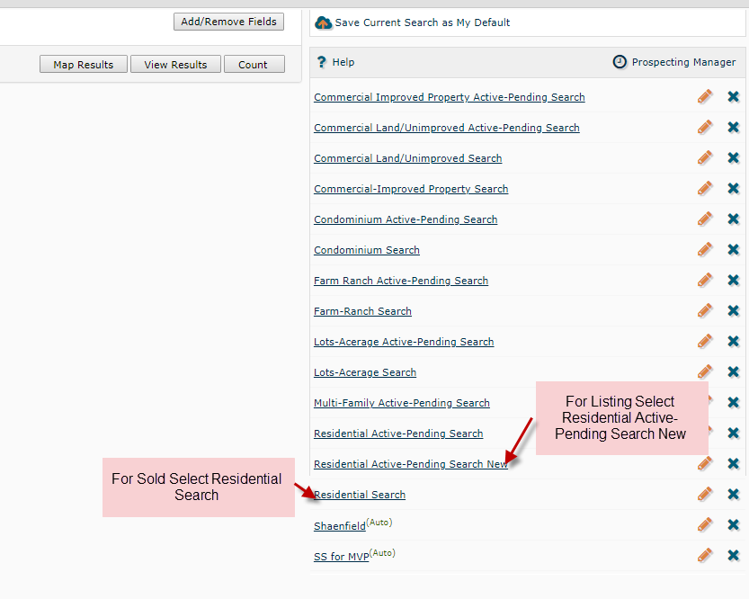
Step 3:
For Listing Files select the entire status in status column except sold, click ok and Enter the required downloading date. Select View Results.
Screenshot 1:
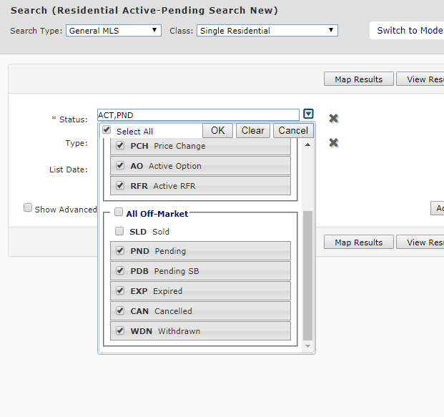

Screenshot 2:
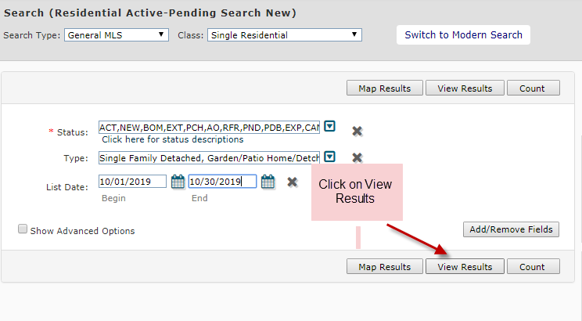
Screenshot 3:
Select all and click on Arrow to download files.

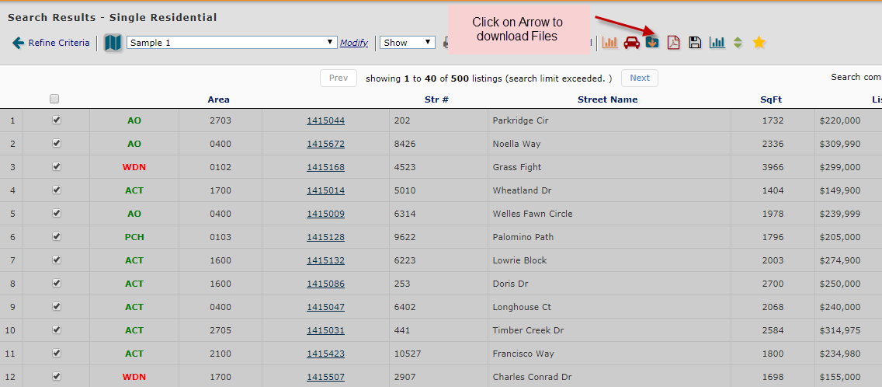

Sold:
For Sold Files select the sold status in status column and click ok and Enter the required downloading date. Select View Results.
Note: Same procedure like Listing
Screenshot:
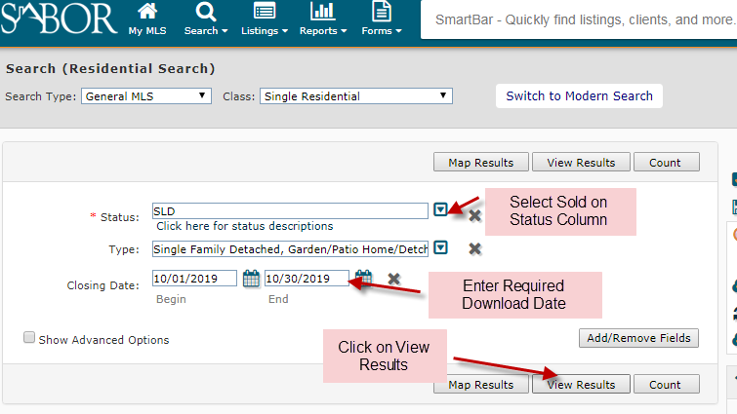

San Other Property Types:
Other property types will be downloaded yearly once. Other property types such as Multifamily, Commercial, Lots , Farm – Ranch & Condominium.
Note: Same Procedure for Commercial, Lots ,Farm – Ranch,Condominium like Residential

Screenshot:
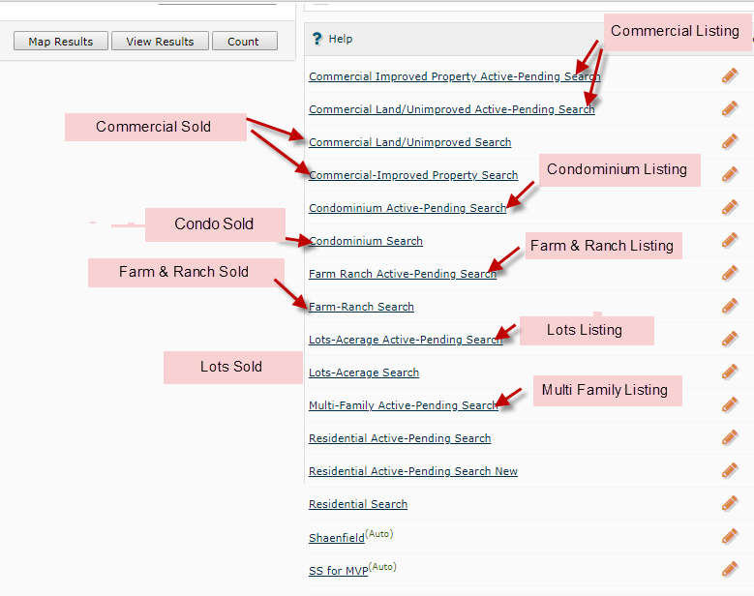

Listing:
Screenshot 1:

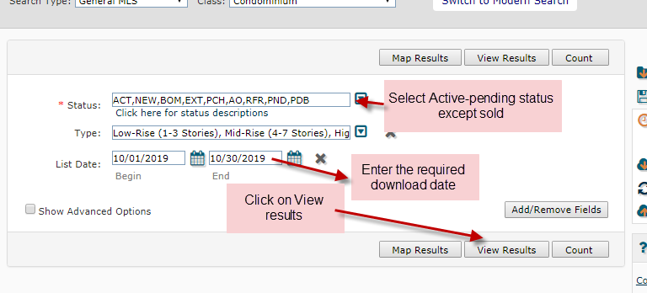
Screenshot 2:
Select all and click on Arrow to download files
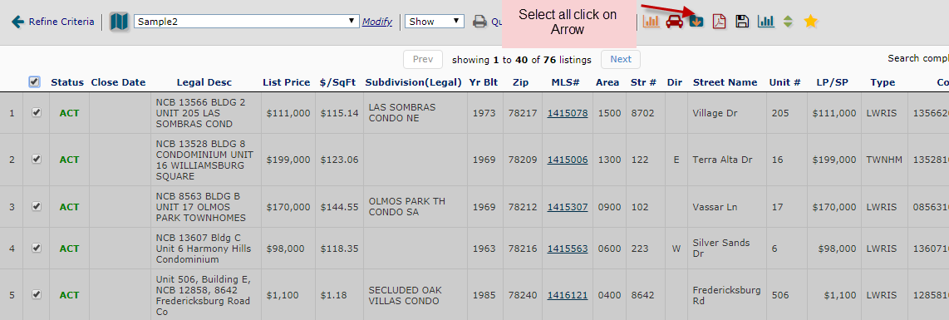

Screenshot 3:
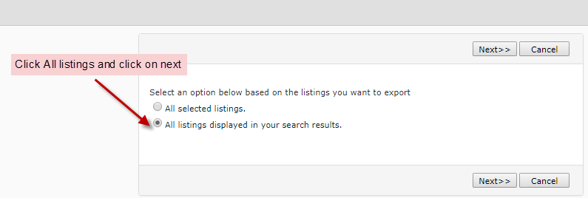

Screenshot 4:

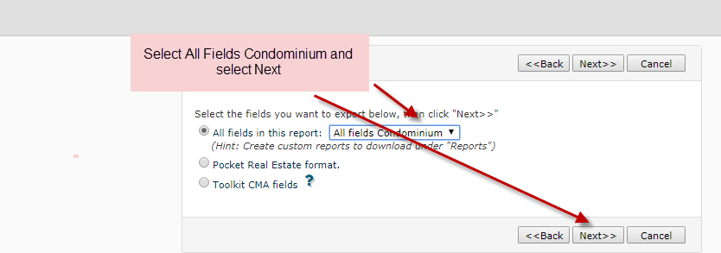

Screenshot 5:
Click on Continue to download files.
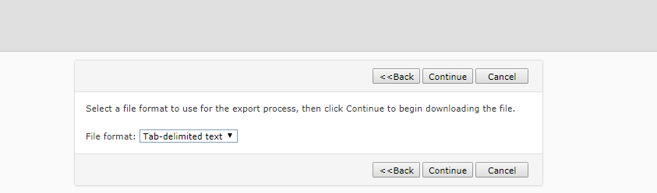

Sold:
For Sold Files select the sold status in status column and click ok and Enter the required downloading date. Select View Results.

Note: Same Procedure like Listing

Screenshot 1:
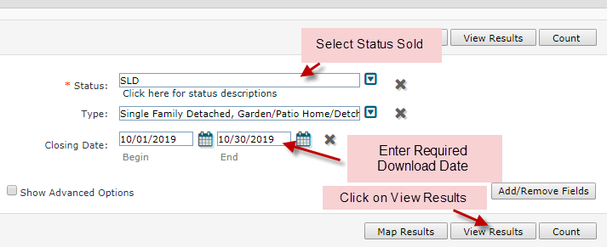

Delimit
Delimit Procedure:

After Downloading Files will be delimited by using below mentioned instructions.

Table:

County Name | Fields to be Formatted in Text | Length Size in excel
Austin | Parcel Number, Mapscogrid ,Mapscopage | Parcel Number-20;State-2 Change the field value as TX;Status-4
Dallas | Key Box number, Parcel Number | Parcel Number-20;State-2 Change  the field value as TX;Status-4
Houston | Map Page, Tax ID | State-2  For Eg:TX;Status-5;Siding-20;Taxid-20
San Antonio | Mapsco Grid, Tax Prop ID,CountyAccnumber | State-2 Change the field value as TX; Status-;PND except ACT,Taxid-20

Batch Creation
- Once the downloading process completed. Create the batch as per the below instruction.
- Consolidate all the downloaded sales
- Change the format to TEXT for the Account Number & MLS Number while delimiting the records.
- Save the file in the Text Format

- While batch creating, for few files account Number will be already exists in database so automatically get mapped. If Account Numbers does not exists in database remaining files will comes for production.

- Open the MLS Automation Tool and follow the instruction given in the image.

Screenshot 1:

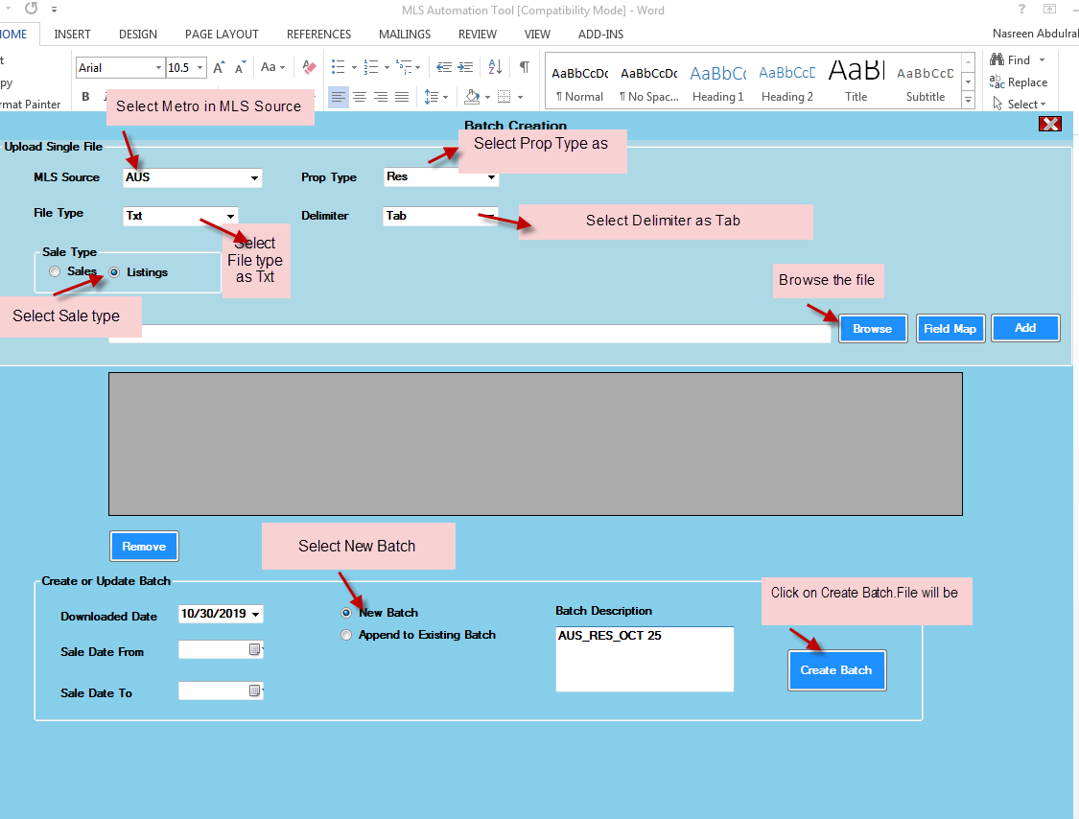

Screenshot 2:
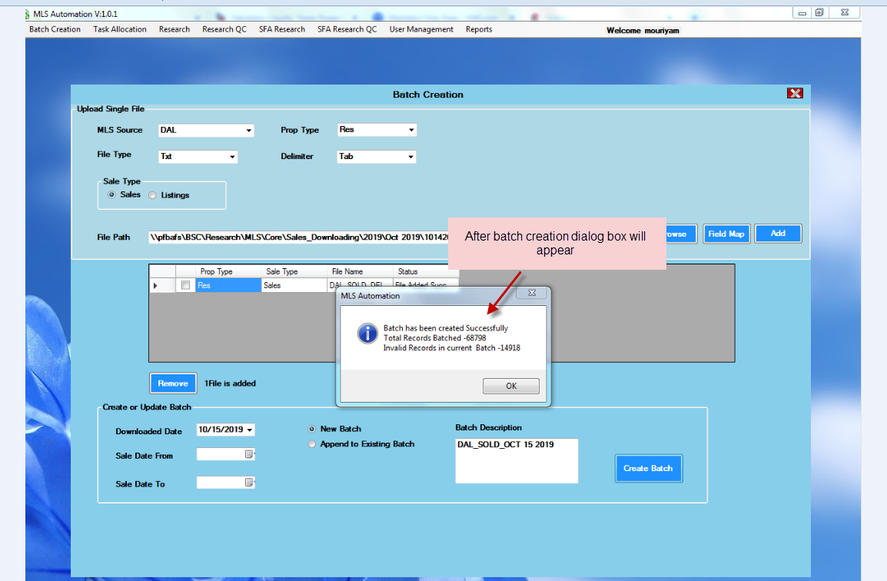

Task Allocation:
After batch creation, files will be allocated for resources in task allocation

Screenshot:
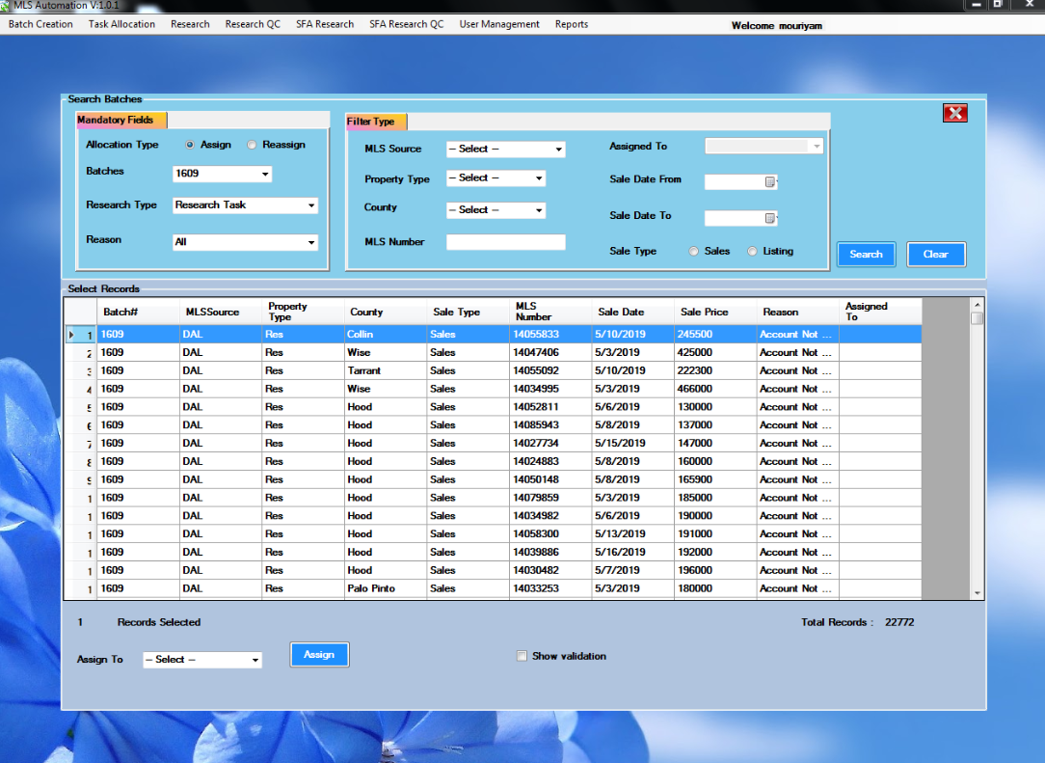

Procedure to Process the Files:
- Open the MLS Automation Tool
- Click the RESEARCH tab to open files
- Click on the sale (as shown below) to open the record.
- Open the respective cad to find the account number
- Using the Parcel Number, Address & Legal Description to find the Account Number, If the Legal Description & Address is matched with the account number, update the account number and save the record as shown below. Updated data will be displayed in tool.
- Enter the LUC based on the property type & Stories
- Complete the file as shown below.

Screenshot:
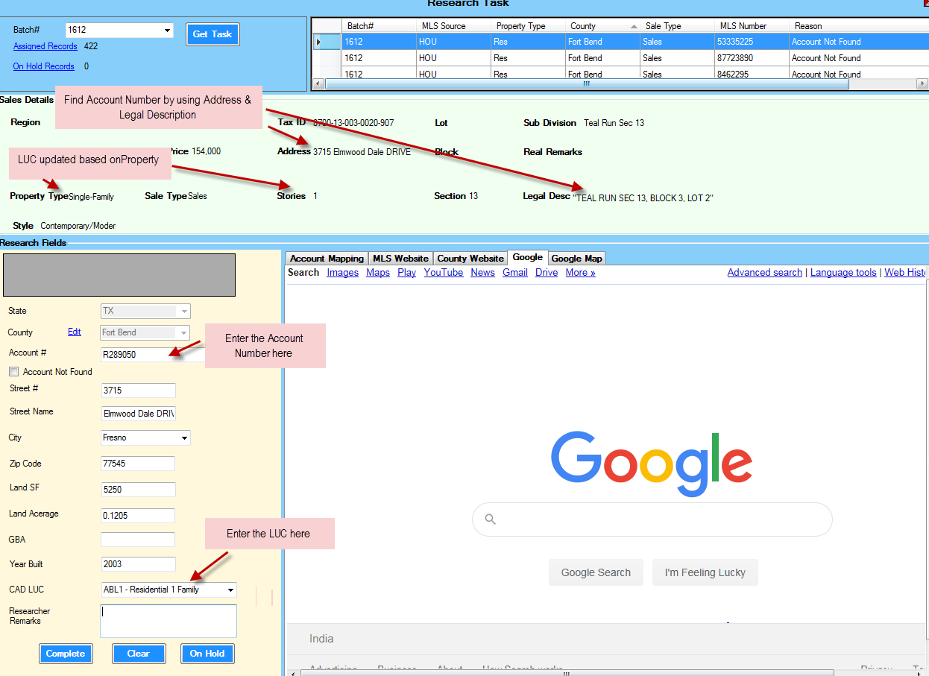

Non-Core Metros

Non-Core Metros:
- 25 Metros available in Non-Core. Currently we working on 6 Metros is mentioned below.

Metros:
- Aransas
- Henderson
- Jefferson
- Kerr
- McLennan
- TAR covers Hardin, Liberty, Waller, Wilson

Aransas Metro:
User id : patoconnor
Password: 6223
Henderson Metro:
User id : oconnorp
Password: oca08
Jefferson Metro:
User id : OCONNORP
Password: 0318
Kerr Metro:
User id : oca08
Password: oca08
McLennan Metro:
User id : 805554499
Password: oca09
Tar Metro:
User id : poconnor
Password: 2009oca

Downloading:
Above 6 Metros will be downloaded using Navica site & Paragon Site

Navica Site:
By using the user id & password enter the Navica site.

Screenshot:
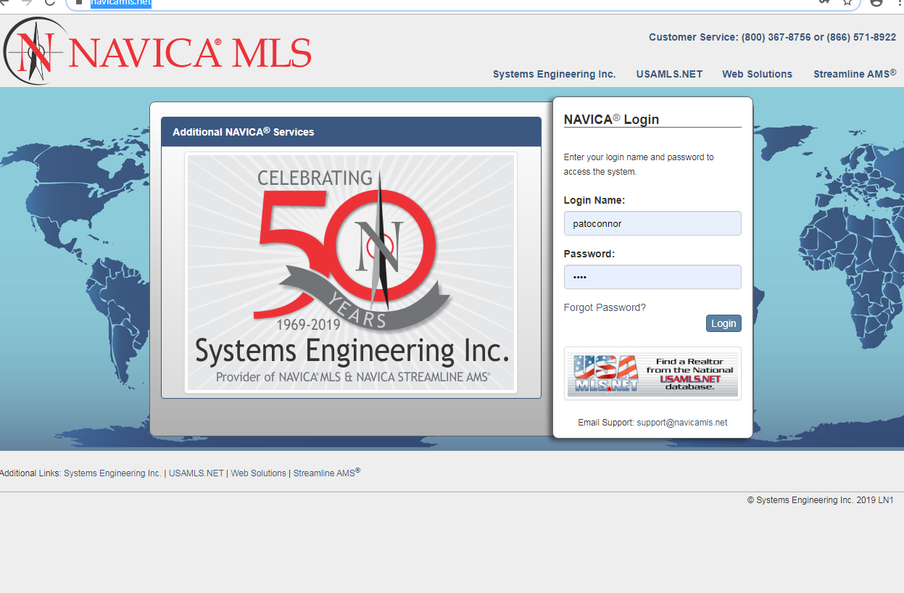
Step 1:
Click on Search button and select required property type such as Multifamily, Residential, Land, and Commercial

Screenshot:
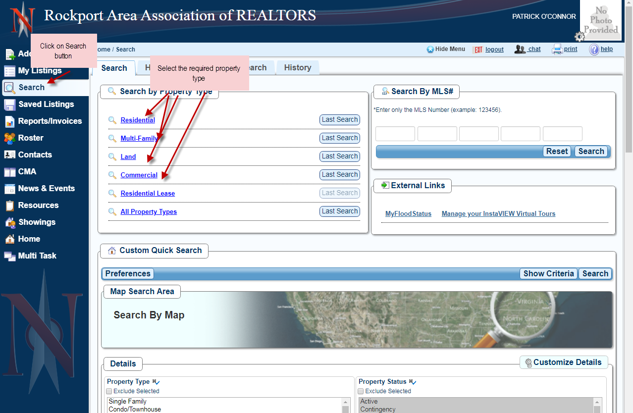

Step 2:
For listing select Active & Under contract to download files and For Sold Select sold.

Screenshot 1:

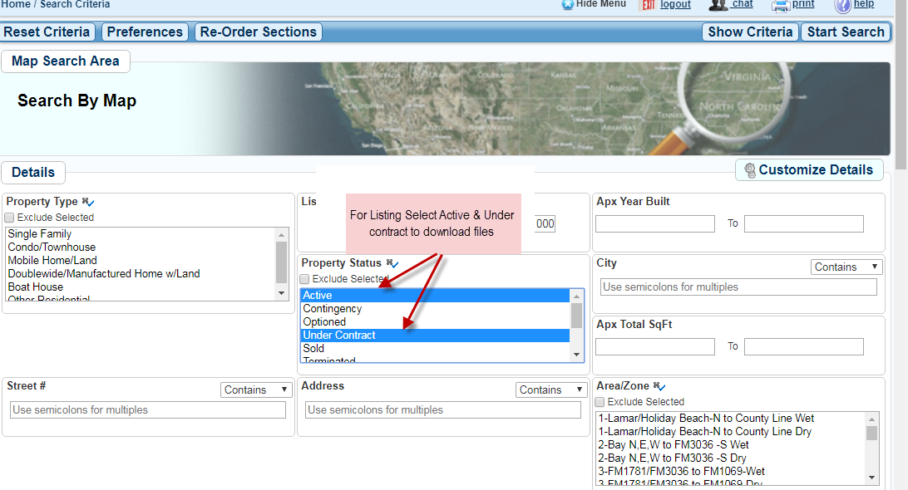

Screenshot 2:
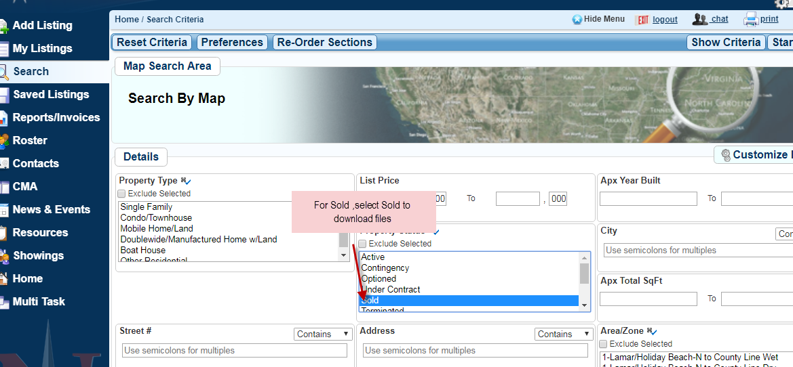

Step 3:
Enter the required download date and click on start criteria.
Screenshot:
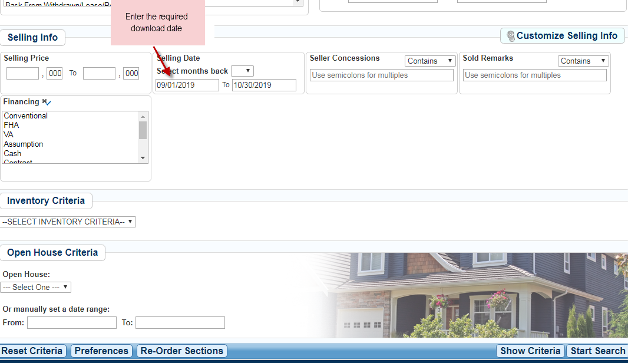

Step 4:

Click on Residential All Fields to export Files
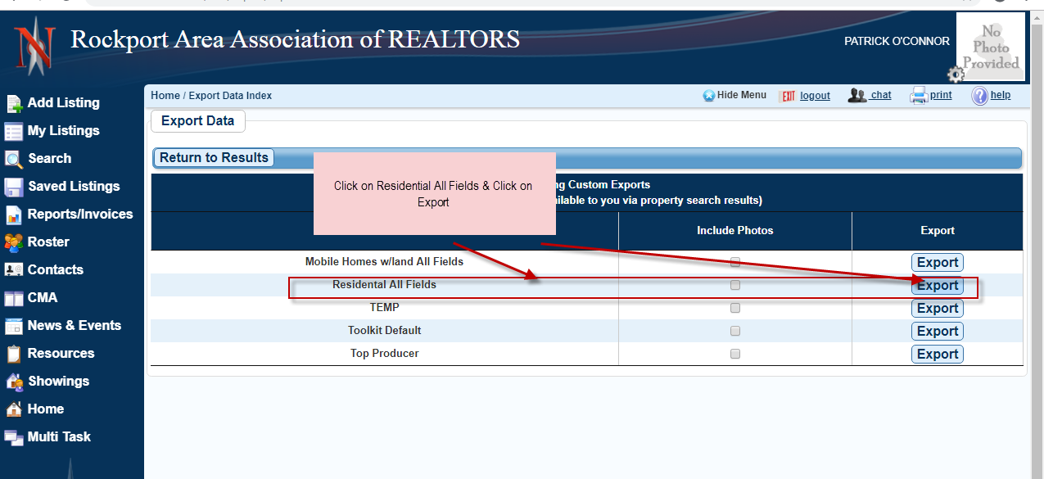

Step 5:
Right click on save link to export the file.
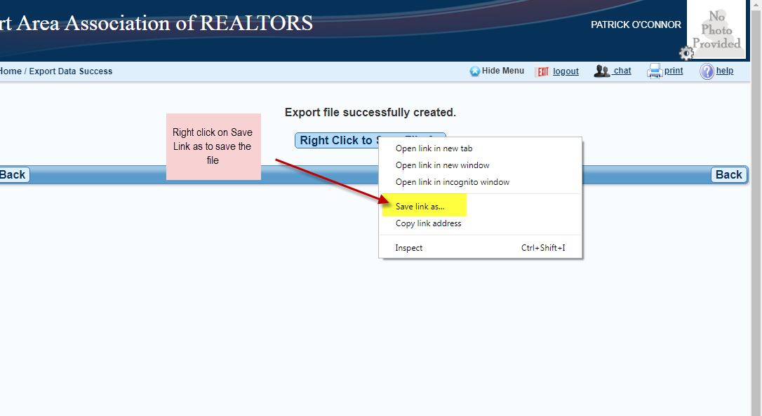

Paragon Site:
By using the user id & password enter the Paragon site.

Screenshot 1:
Click on Search button and Select the required property type such as Residential, Office, Land, Multifamily & Commercial.

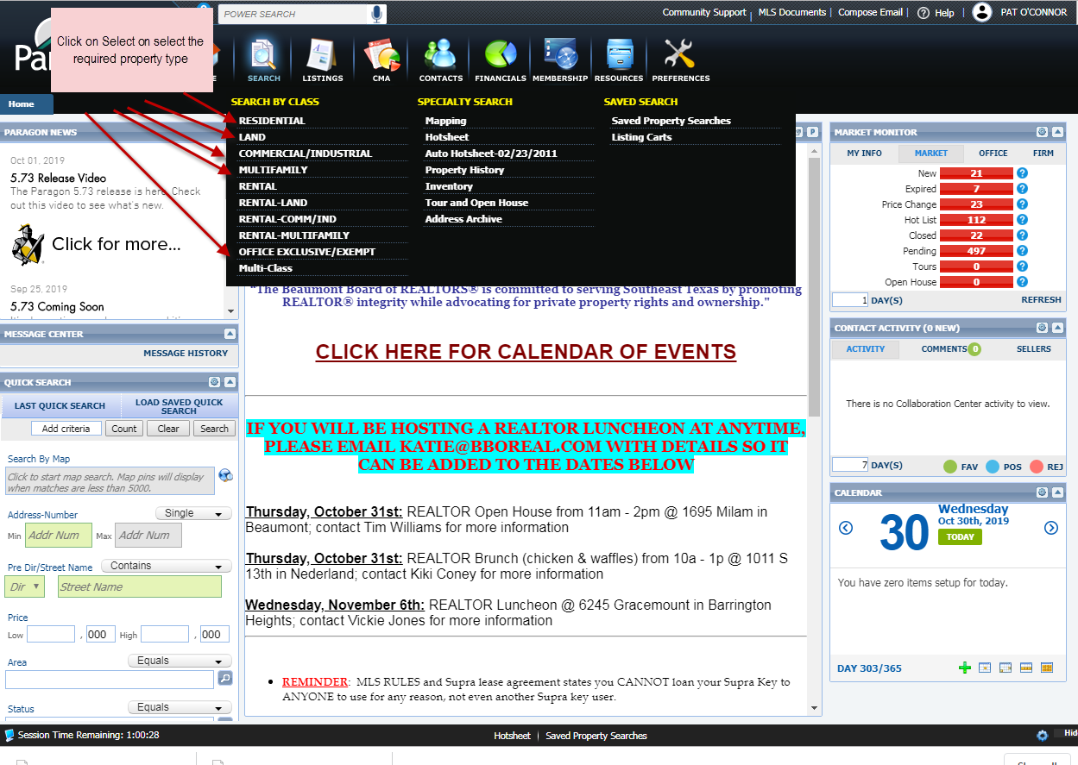

Screenshot 2:
For Listing Select on Active and Pending to download the files. For Sold select Closed type.
Listing:
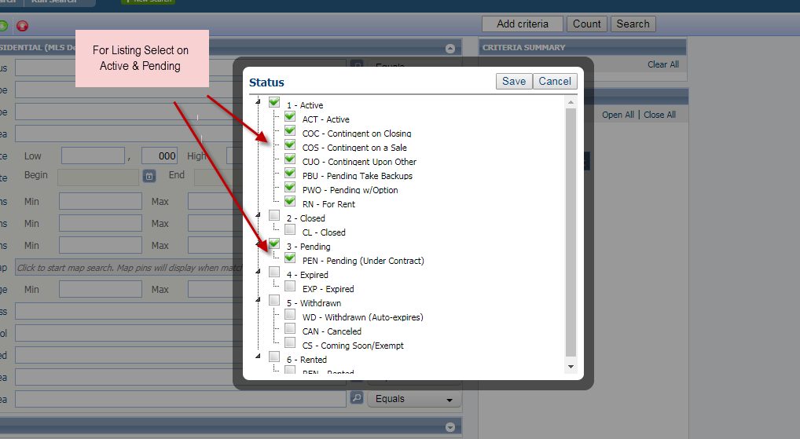
Sold:
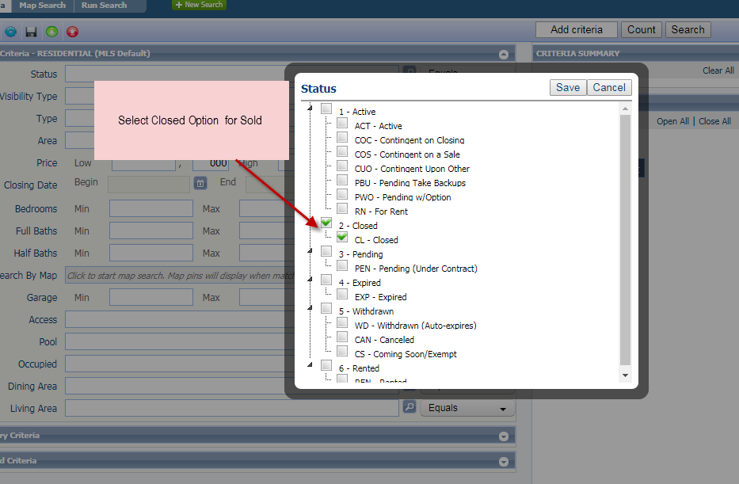

Screenshot 3:

Select the entire property type.
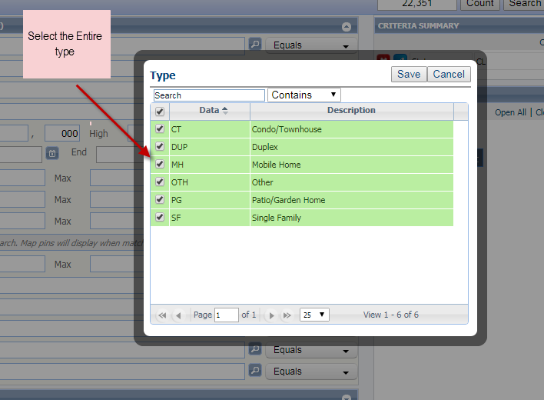

Screenshot 4:
Enter the required date in date field and click on search option
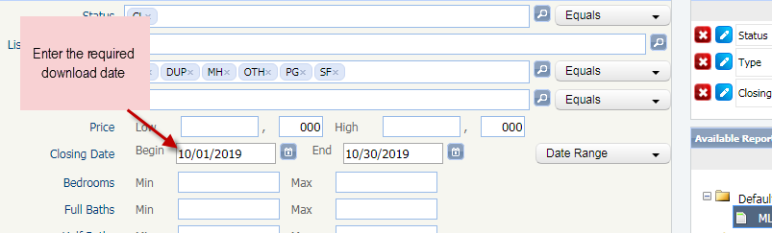

Screenshot 5:
Click on MLS-default and Select all.
Note: Before Downloading the files check all headers in Preference Column.S

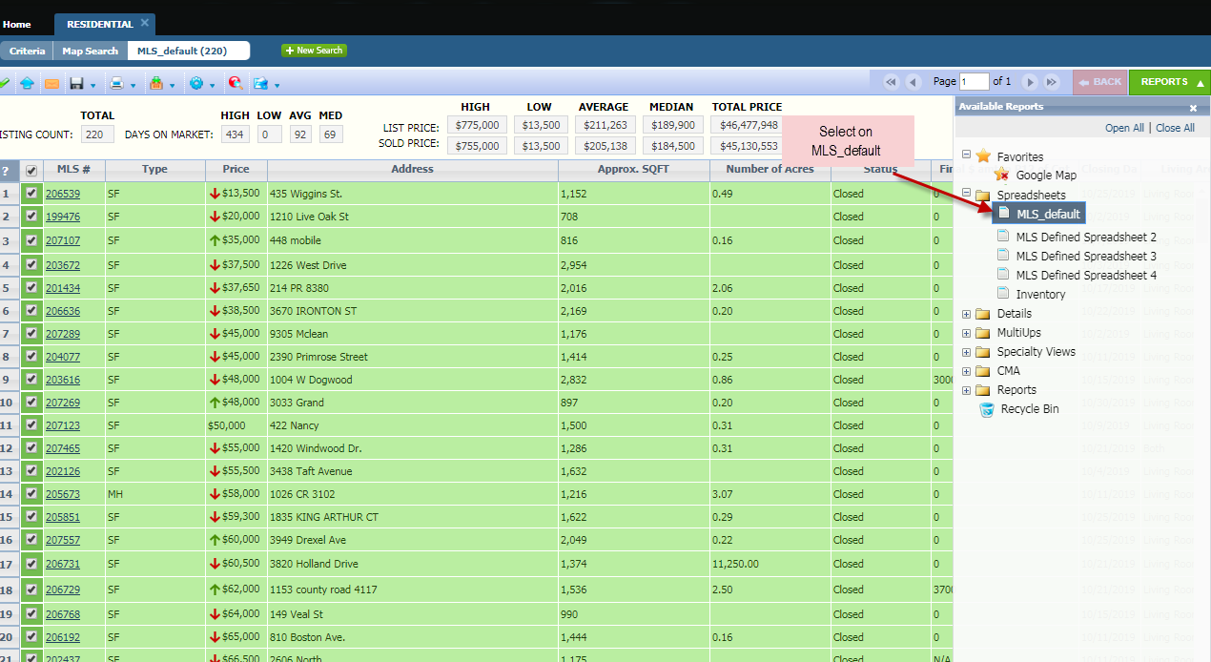
Screenshot 6:
Click on export to download the files
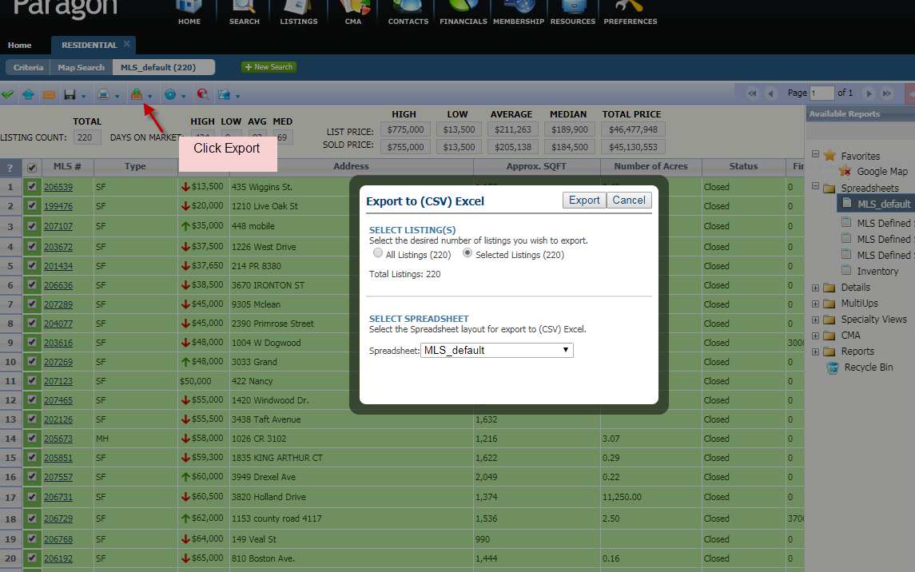

Screenshot 7:
Select All Listings and click on Export.
